**A Method for Microbiome-Based Prediction, Diagnosis, and Treatment of Relapsing Obesity:**

**A Novel Method for Maintaining Target Body Weight Following Weight Loss Intervention Using Gut Microbiome Analysis**

|  |  |
| --- | --- |
| **Project Number:** | 1781 |
| **Principal Investigators:** | Prof. Eran Elinav  Prof. Eran Segal |
| **Patent Status:** | Pending |

**Overview**

**A novel method for analyzing the likelihood of weight regain following a weight loss program and maintaining target body weight, based on gut microbiome analysis.**

**Background and Unmet Need**

The past century has seen an overwhelming increase in the prevalence of overweight and obese individuals, effecting over a third of the world’s population today. Obesity is strongly associated with conditions such as stroke, diabetes, high blood pressure, musculoskeletal disorders, and ischemic heart disease, the latter being considered a leading cause of overall mortality.

Despite continuous efforts to find a solution for the obesity epidemic, no dietary approach has been able to maintain prolonged weight reduction after the initial weight loss. Moreover, the recurrent weight gain usually exceeds that of the pre-weight loss intervention, irrespective of fitness level or genetic background. The health risks are further increased with each weight gain-loss cycle.

**Consequently, there is a strong need for the development of novel methods for weight loss and more importantly, for stopping relapsing obesity post-weight loss intervention.**

**The Innovation**

The teams of Profs. Elinav and Segal have developed a method for analyzing the gut microbiome and inferring the likelihood of weight regain from the presence/absence of specific microbes.

**The Technical Essence:**

The Elinav-Segal research teams discovered that the amount and composition of certain microbes in the gut contribute to accelerated post-dieting weight regain. Therefore, down regulating certain microbes that are associated with weight gain while simultaneously upregulating microbes associated with weight loss can help achieve and maintain the target weight. The developed method consists of:

1. Treating the individual with a dieting aid.
2. Monitoring the amounts of different gut microbes indicative of weight gain/loss.
3. Administering an agent that alters the gut microbiome signature to that similar to non-obese individuals.

The researchers have developed a personalized machine-learning algorithm, which based on the gut microbiome population, can predict the likelihood of recurrent weight gain. Additionally, the researchers have tested different agents such as antibiotics, flavanoids, and fecal transplants in mouse models, to directly modulate the gut microbiome to avoid relapsing obesity.

**Applications and Advantages:**

* **Diagnostic to test which populations are more susceptible to relapsed obesity**
* **A method of either using an agent or a specific bacterial population to reduce relapsed obesity**

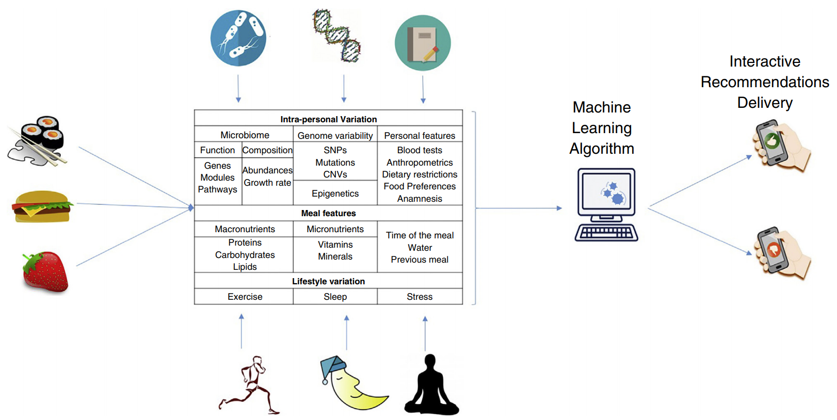

Data collected by monitoring the subject’s microbiome population can indicate the possibility of weight regain. This information can be used to modulate the subject’s diet or to directly modify the gut-microbiome population.

**Development Status**

The teams of Profs. Elinav and Segal have developed a personalized machine-learning algorithm enabling microbiome based prediction of relapsing weight gain and have demonstratedin mice, that fecal transplantation and post-biotic intervention may prevent excessive secondary weight gain. This research has been published in the prestigious scientific journal of [*Nature*](https://www.nature.com/articles/nature20796)*[1] .*

**For additional information please contact:**

Dr. Shay Sela  
VP Business Development Life Sciences  
Tel: +972.8.9344095  
Email: Shay.Sela@weizmann.ac.il

1. Thaiss CA et al. Persistent microbiome alterations modulate the rate of post-dieting weight regain. Nature. 2016 Nov 24. doi: 10.1038/nature20796,